Assignment-4

1.Pull an image from docker hub and run it in docker playground.

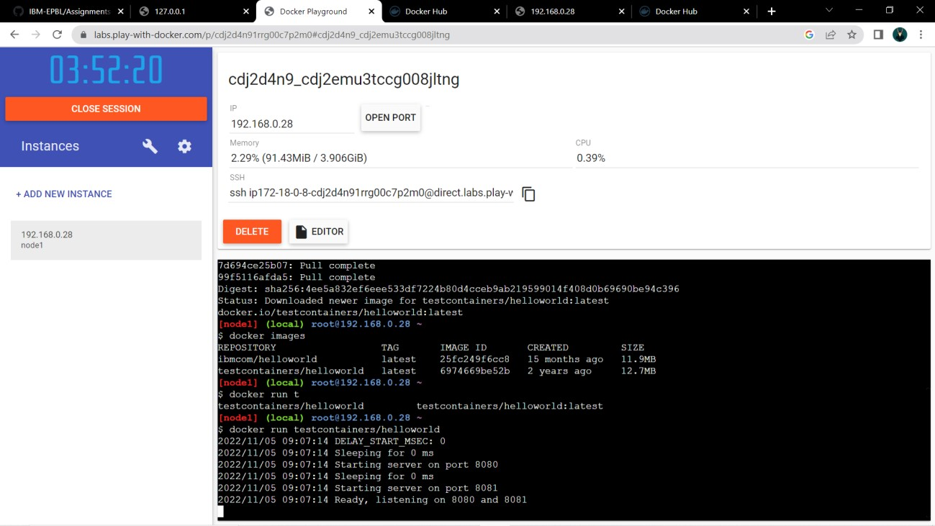

2.Create a docker file for the jobportal application and deploy it in docker desktop application.

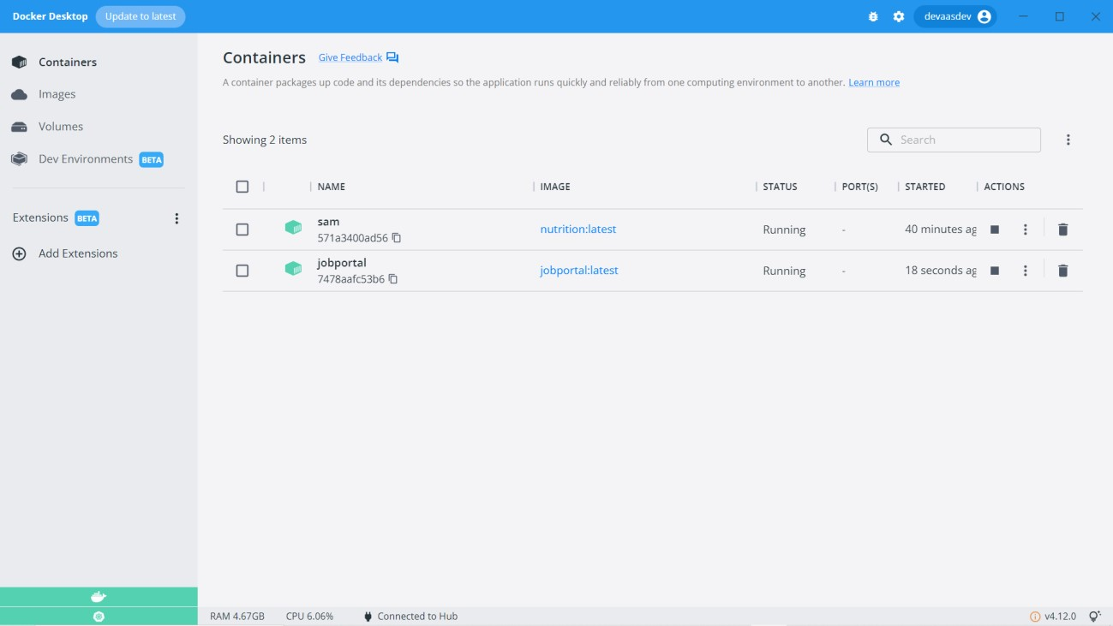

3.create an IBM container registry and deploy hello world app or jobportalapp.

